AI ASSISTED CODING
LAB 3.2
NAME: K.srinija
HT NO: 2303A52474
BATCH 39

Question 1
Prompt
Write a function called calculator
>> it becomes incomplete
Write a calculator function that supports addition, subtraction, multiplication, and division using an operator parameter

Code
"""
OPTIMIZED CALCULATOR PROGRAM
A simple, efficient calculator with arithmetic operations

Features: Addition, Subtraction, Multiplication, Division, Power, Modulo, Square Root
"""

# Operation functions using dictionary for efficient dispatch
def calculate(op, x, y=None):
"""
Unified calculation function - handles all operations efficiently

Parameters:
op (str): Operation ('+', '-', '*', '/', '^', '%', 's')
x (float): First number
y (float): Second number (optional for sqrt)

Returns:
float/str: Result or error message

Examples:
>>> calculate('+', 5, 3)
8
>>> calculate('*', 4, 7)
28
>>> calculate('/', 20, 4)
5.0
>>> calculate('s', 16)
4.0
"""
# Validate operations requiring two operands
if op in ['+', '-', '*', '/', '^', '%'] and y is None:
return "Error: This operation requires two numbers"

# Perform calculation based on operation
if op == '+':
return x + y
elif op == '-':
return x - y
elif op == '*':
return x * y
elif op == '/':
return "Error: Cannot divide by zero" if y == 0 else x / y
elif op == '^':
return x ** y
elif op == '%':
return "Error: Cannot calculate modulo with zero" if y == 0 else x % y
elif op == 's':
return "Error: Cannot calculate square root of negative number" if x < 0 else x ** 0.5
else:
return "Invalid operation"

def display_menu():
"""Display calculator menu"""
print("\n" + "="*50)
print("CALCULATOR")
print("="*50)
print("\n1. Addition (+) 2. Subtraction (-) 3. Multiplication (*)")
print("4. Division (/) 5. Power (^) 6. Modulo (%)")
print("7. Square Root (√) 8. Exit")
print("-"*50)

def run_calculator():
"""Main interactive calculator loop"""
while True:
display_menu()
choice = input("Enter choice (1-8): ").strip()

if choice == '8':
print("\nThank you for using the calculator!\n")
break

try:
if choice in ['1', '2', '3', '4', '5', '6']:
# Operations requiring two numbers
x = float(input("Enter first number: "))
y = float(input("Enter second number: "))

ops = {'1': '+', '2': '-', '3': '*', '4': '/', '5': '^', '6': '%'}
result = calculate(ops[choice], x, y)

symbols = {'+': '+', '-': '-', '*': '×', '/': '÷', '^': '^', '%': '%'}
print(f"\n{x} {symbols[ops[choice]]} {y} = {result}")

elif choice == '7':
# Square root operation
x = float(input("Enter number: "))
result = calculate('s', x)
print(f"\n√{x} = {result}")

else:
print("\nInvalid choice. Please select 1-8.")

except ValueError:
print("\nError: Please enter valid numbers")

# ================================================================================
# MAIN PROGRAM
# ================================================================================

if __name__ == "__main__":
"""
Usage Examples:

1. INTERACTIVE MODE:
python 3.2_calculator.py

2. QUICK CALCULATIONS (import):
from 3.2_calculator import calculate

calculate('+', 10, 5) # 15
calculate('-', 20, 8) # 12
calculate('*', 6, 7) # 42
calculate('/', 100, 4) # 25.0
calculate('^', 2, 8) # 256
calculate('%', 17, 5) # 2
calculate('s', 144) # 12.0
"""
run_calculator()

if __name__ == "__main__":
run_calculator()

Output
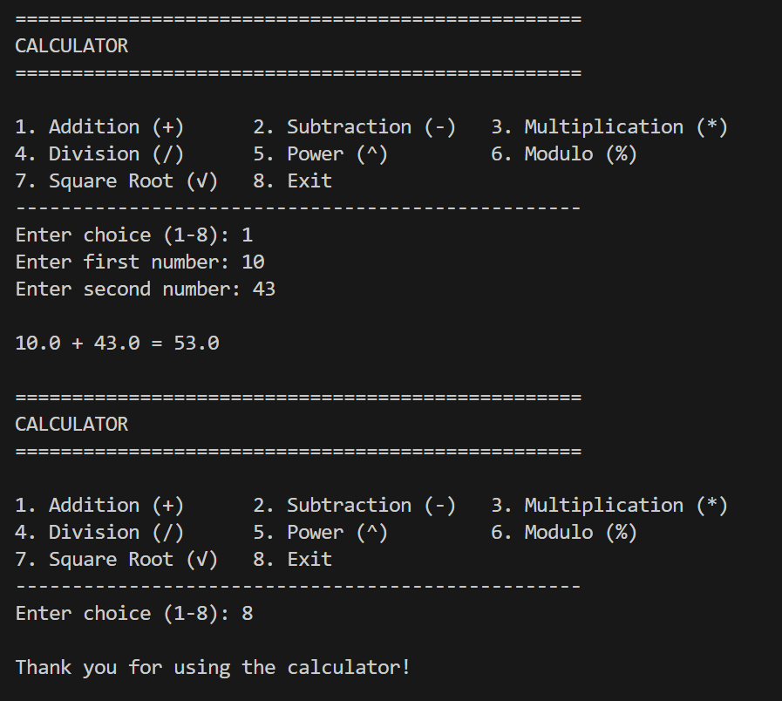
Analysis
This optimized calculator demonstrates how clear structure, comprehensive features, and strong validation produce a robust, reusable, and user-friendly program compared to a basic prompt-generated function.

Question 2
Prompt
Sort students marks
>> this uses the inbuilt sort function
Sort students marks in descending order without using the inbuilt function

Code
def sort_marks_desc(marks):
n = len(marks)

for i in range(n):
for j in range(i + 1, n):
if marks[i] < marks[j]:
marks[i], marks[j] = marks[j], marks[i]

return marks

# ---- User Input ----
n = int(input("Enter number of students: "))
marks = []

for i in range(n):
m = int(input(f"Enter mark of student {i+1}: "))
marks.append(m)

# ---- Sorting ----
sorted_marks = sort_marks_desc(marks)

# ---- Output ----
print("Marks in descending order:", sorted_marks)

Output
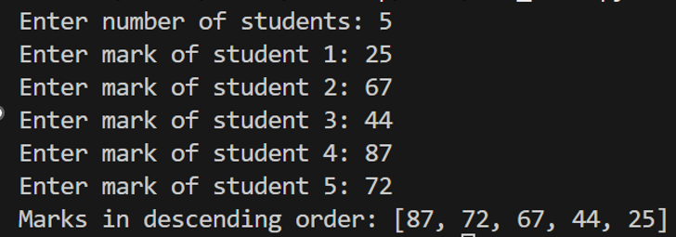

Analysis
Clear constraints (no inbuilt functions and user input) force the implementation of explicit comparison-and-swap logic, resulting in a correct and transparent descending sort algorithm.

Question 3
Prompt
Program to determine if a number is prime or composite. Example 19->prime, 20->composite
Code
import math

def classify_number(number):
"""
Classify a number as Prime, Composite, or Neither.

Prime: A number > 1 with exactly 2 divisors (1 and itself)
Composite: A number > 1 with more than 2 divisors
Neither: Numbers 0 and 1

Args:
number: An integer to classify

Returns:
A string indicating the classification
"""
# Handle special cases
if number <= 1:
return "Neither"

# Check if number is 2 (only even prime)
if number == 2:
return "Prime"

# Even numbers greater than 2 are composite
if number % 2 == 0:
return "Composite"

# For odd numbers, check divisibility up to sqrt(number)
# Optimization: Only check odd divisors up to square root
for i in range(3, int(math.sqrt(number)) + 1, 2):
if number % i == 0:
return "Composite"

return "Prime"

# Main program
if __name__ == "__main__":
# Get user input
user_input = input("Enter a number: ")
try:
number = int(user_input) # Convert input to integer
result = classify_number(number)
print(f"{number} → {result}")
except ValueError:
print("Please enter a valid integer.")

Output
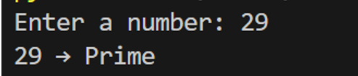
Analysis
Few shot prompting guided the AI accurately with the help of multiple examples. Provides accurate output

Question 4
Prompt:
Create a simple UI where user enters marks for 5 subjects, calculate total, percentage, and grade

Code
def calculate_grade(percentage: float) -> str:
"""
Calculate grade based on percentage.

Args:
percentage (float): The percentage score

Returns:
str: The grade (A, B, C, D, F)

Grade Scale:
A: 90-100%
B: 80-89%
C: 70-79%
D: 60-69%
F: Below 60%
"""
if percentage >= 90:
return 'A'
elif percentage >= 80:
return 'B'
elif percentage >= 70:
return 'C'
elif percentage >= 60:
return 'D'
else:
return 'F'

def get_marks_input() -> list:
"""
Get marks for 5 subjects from user input.

Returns:
list: List of 5 marks (integers)
"""
subjects = ['English', 'Mathematics', 'Science', 'Social Studies', 'Computer Science']
marks = []

print("\n" + "="*50)
print(" GRADING SYSTEM")
print("="*50)
print("Enter marks for 5 subjects (0-100):\n")

for subject in subjects:
while True:
try:
mark = int(input(f"Enter marks for {subject}: "))
if 0 <= mark <= 100:
marks.append(mark)
break
else:
print("❌ Please enter marks between 0 and 100")
except ValueError:
print("❌ Please enter a valid number")

return marks

def display_results(marks: list):
"""
Display total, percentage, and grade.

Args:
marks (list): List of 5 marks
"""
subjects = ['English', 'Mathematics', 'Science', 'Social Studies', 'Computer Science']

total = sum(marks)
max_marks = 500 # 5 subjects * 100
percentage = (total / max_marks) * 100
grade = calculate_grade(percentage)

print("\n" + "="*50)
print(" RESULTS")
print("="*50)

for subject, mark in zip(subjects, marks):
print(f"{subject:.<25} {mark}/100")

print("-"*50)
print(f"{'Total Marks':.<25} {total}/{max_marks}")
print(f"{'Percentage':.<25} {percentage:.2f}%")
print(f"{'Grade':.<25} {grade}")
print("="*50 + "\n")

def main():
"""Main function to run the grading system."""
try:
marks = get_marks_input()
display_results(marks)

# Option to run again
while True:
choice = input("Do you want to check another student's grades? (yes/no): ").lower()
if choice in ['yes', 'y']:
marks = get_marks_input()
display_results(marks)
elif choice in ['no', 'n']:
print("Thank you for using the Grading System!\n")
break
else:
print("❌ Please enter 'yes' or 'no'")
except KeyboardInterrupt:
print("\n\nProgram terminated by user.")

if __name__ == "__main__":
main()

Output
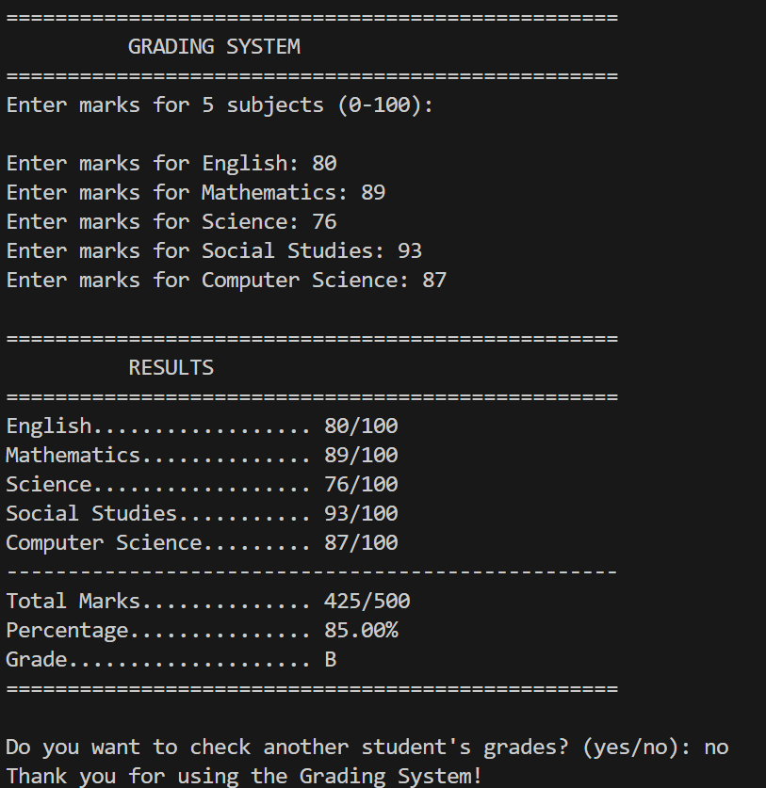

Analysis
The clear and specific prompt guides the AI to generate a structured UI with accurate calculations, meaningful user interaction, and better code organization instead of a basic program.

Question 5
Prompts:
Write unit converter
>> doesn’t give clear code
Write functions to convert kilometers to miles and miles to kilometers

code
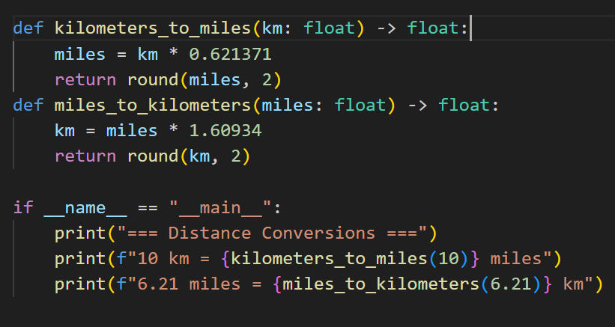

Output
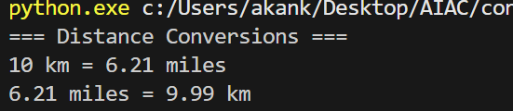

Analysis
As prompt specificity increases, code becomes more accurate, readable, reusable, and professional.

